DIY LOGIC PROBE Rev. 1.1

Having a logic probe handy is always a must for an electronics workshop. But instead of buying one why not build your own for a fraction of the cost and have it working in an hour?

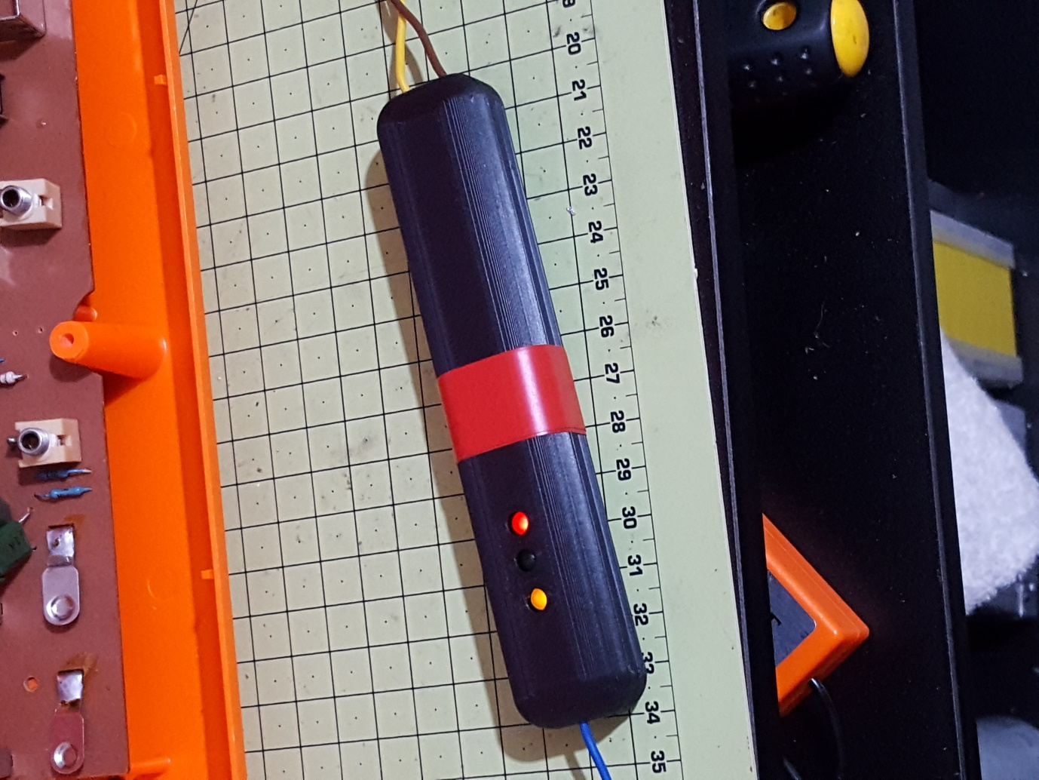

# *Why Do I Need a Logic Probe?*

This device cannot show you what a waveform looks like, unlike an oscilloscope, but it can tell you whether a signal is

off (0),

on (1),

floating (Z), or

oscillating

The advantage of a logic probe is that it is a very simple circuit that is so small that it can be held like a pen. It is also dead cheap.

## Floating Input

If the input is not connected to anything (floating), the logic gate U1A will oscillate thanks to R1. The NOR gate is behaving as a NOT gate (as both inputs are tied together) with the output connected to the input (through R1). If the output is logic high, then the input voltage will be high as well—but if the input voltage is high, then the output voltage should be low (as it is an inverter). It is this “out of phase” setup that causes U1A to oscillate (where the frequency of oscillation is determined by the resistor R1 and the input capacitance of U1A).

So what will happen when U1A oscillates (because the probe is floating)? Because the oscillation does not go to VDD and GND, the Green and Red LED (Hi and Low, respectively) will be off or dim depending on the size of R2 and R3. U1B and U1C are configured as a monostable multivibrator (the off period being determined by R4 and C2) with an inverting output stage (U1D) which is connected to an LED (D3). When the output voltage of U1A makes a low-to-high transition, the monostable is triggered and will turn on the Yellow LED (D3) to indicate that the input signal has changed. With U1A oscillating (as the input is floating and the feedback resistor R1 causes U1A to oscillate), the monostable is constantly triggered by U1A and thus the oscillating indicator (D3) will stay on.

For this circuit configuration, the monostable off period is approximately 0.47s.

## Oscillating Signal

When the probe is connected to an oscillating signal (one that swings between VDD and GND), not only is the oscillating indicator (D3) on but so are D1 and D2.

Note: The logic probe will also give you some idea of the duty cycle of the signal under test. If the signal has a high duty signal (for example, 90% on 10% off) the HI LED (D1) will be much brighter than the LO LED (D2).

## ON / OFF Signals

When the probe is connected to either an ON or OFF signal, the oscillating indicator (D3) will turn off because the monostable is not being triggered (as the input signal to the logic probe is not changing). If the input is ON, then the HI LED (D1) will turn on. If the input is OFF, then the LO LED (D2) will turn on.

## Grounding

For the probe to function correctly, the ground on the logic probe and the ground on the circuit under test must be connected. This is where the 0V ref pad comes into play. This pad gives you a place to connect your probe's ground to the ground of the circuit under test.

Enclosure

Construction

# Using the Logic Probe

Using the logic probe is very simple:

Make sure the probe has power (5V to 9V).

Connect the probe's ground to the ground of the circuit that you are testing.

Probe the circuit.

The table below shows the combination of LEDs and what they represent.

|  |  |  |  |
| --- | --- | --- | --- |
| Function | R/Lo LED | Y/Osc LED | G/Hi LED |
| On | OFF | OFF | ON |
| Off | ON | OFF | OFF |
| Oscillating | ON | ON | ON |
| Floating | OFF | ON | OFF |

# Schematic

[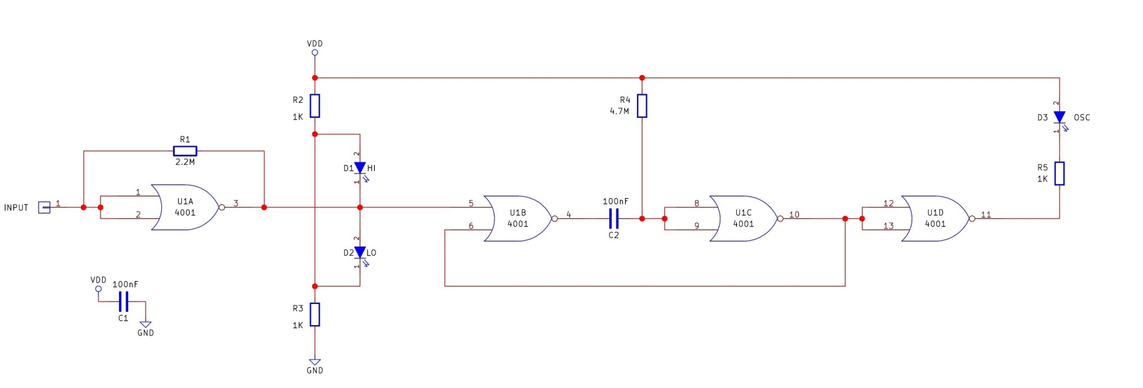](https://www.allaboutcircuits.com/uploads/articles/LogicProbeSchematicV1.jpg)

# PCB

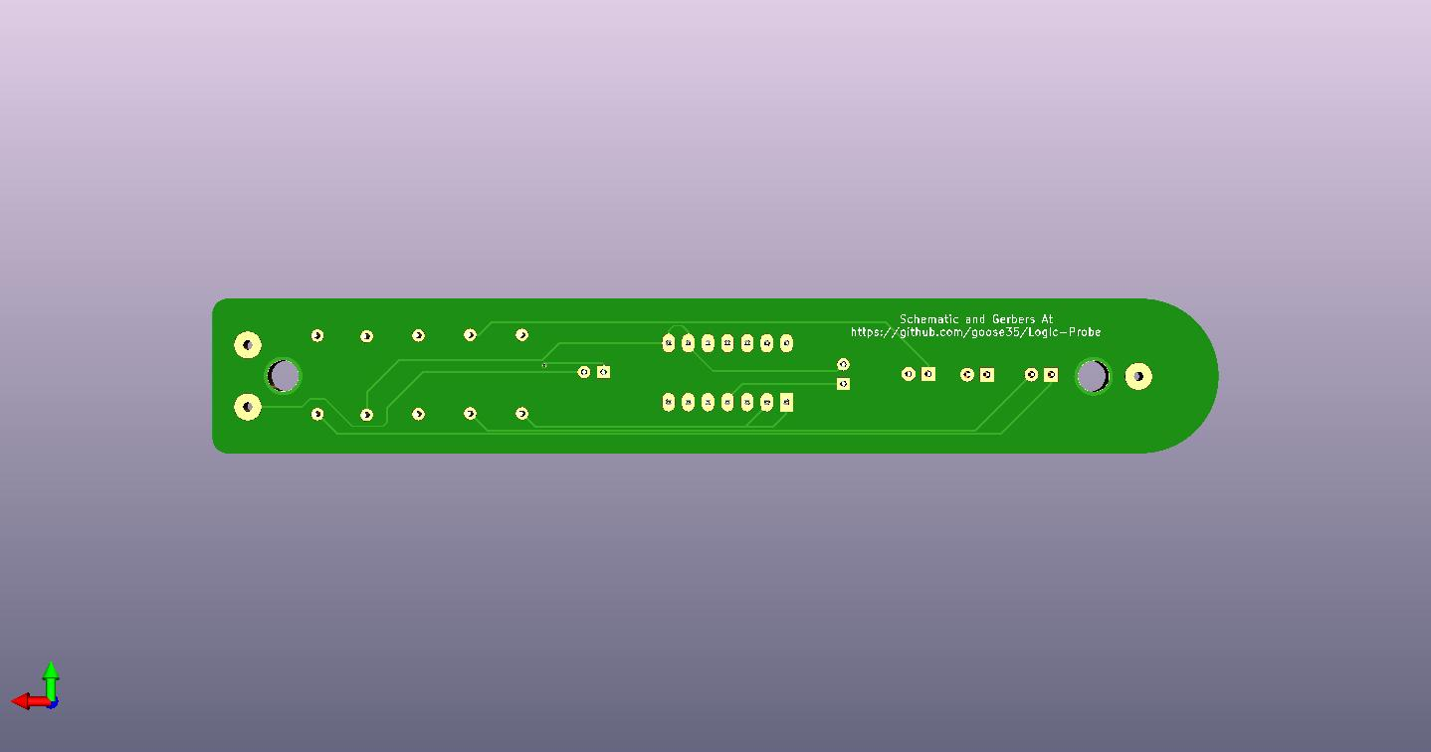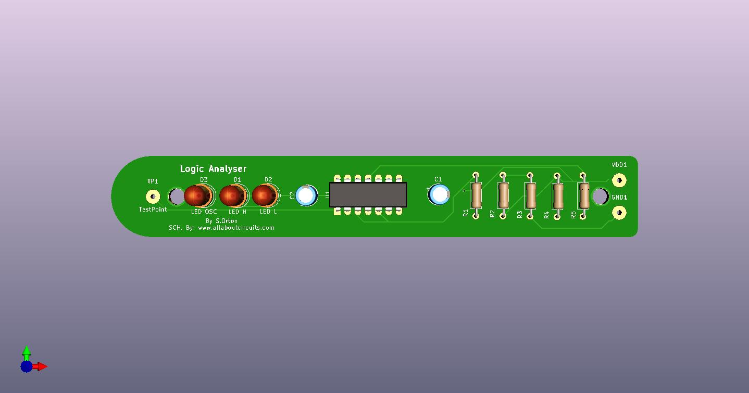

# BOM—Bill of Materials

## Logic Probe PCB

|  |  |  |
| --- | --- | --- |
| Component / Part | Schematic Reference | Quantity |
| 4001 IC | U1 | 1 |
| 1K Resistor | R2, R3, R5 | 3 |
| 2.2M Resistor | R1 | 1 |
| 4.7M Resistor | R4 | 1 |
| 100nF Capacitor | C1, C2 | 2 |
| LED Green (3mm) | D1 | 1 |
| LED Red (3mm) | D2 | 1 |
| LED Yellow (3mm) | D3 | 1 |

## Other

|  |  |
| --- | --- |
| *Component / Part* | *Quantity* |
| PCB | 1 |
| Pogo Pin/Probe steel | 1 (or use wire with probe on) |
| Wire | as needed |
| Croc clips | 2 |
| Electrical Tape/shrink wrap | as needed |

# Case

STL files included for 3d printing an enclosure that fits well in the hand.

Printer settings as follows:-

Material: PLA

Nozzle Dia: 0.4

Layer height: 0.2

Support: Use tree support where possible

Skirt: Yes

Infill: 33% or higher

## Change Log

|  |  |  |  |
| --- | --- | --- | --- |
| Date | Doc Rev. | Board Rev. | Change |
| 04/03/2020 | 1.0 | 1.1 | First Release |
| 05/03/2020 | 1.1 | 1.1 | 3d Printer settings section added for printing STL files  Change log added |